**MATERIAL DE APOIO/ Inglês Instrumental**

**Curso de Eletrotécnica**

Read the definitions and try to answer the following questions:

1. What is the difference between AC (alternating current ) and DC (direct current)?

2. Define ‘electromagnetic induction’.

3. What’s a dynamo?

4. What is an electric motor?

5. What is the difference between an electric motor and a generator?

Definitions:

**1. AC (alternating current)** = “an electric current that reverses its direction many times a second at regular intervals, typically used in power supplies”.

**2. DC (direct current)** = “an electric current flowing in one direction only”.

**3. motor** - **electric motor** = “a device that changes power into movement, used to make machines work”; a device that changes electric power into movement.

**4**. **electric generator** = “machine for producing electric energy / dynamo or similar machine for converting mechanical energy into electricity”.

**5. electromagnetic** = “having both electrical and magnetic properties / of or relating to the interrelation of electric currents or fields and magnetic fields”.

**6. induction** = the production of an electric or magnetic state by the proximity ( with-out contact) of an electrified or magnetized body”/ “ the production of an electric current in a conductor by varying the magnetic field applied to the conductor”.

**7. excitation** = “current in a coil that gives rise to a m.m.f.( MagnetoMotive Force) in a magnetic circuit, especially in a generator or motor.”

**8. magnetic field** = “ region around a magnetic material or a moving electric charge within which the force of magnetism acts.”

Read the text below.

*The 19th century witnessed a major scientific breakthrough: the discovery of the principles that later on were to lay the foundation for electrical engineering, the branch of science and technology concerned with the design, building and use of motors, machines and structures.*

*Two closely related physical phenomena are involved, magnetism and electricity, and the principles are the principle of electromagnetic induction and the principle of reversibility of electromagnetic movement and electromagnetic induction.*

*The first was discovered by the British physicist Michael Faraday in 1831; it states that ‘if a conductor is moved through a magnetic field or if the strength of a stationary conducting loop is made to vary, a current is set up or induced in the conductor; in other words, if a wire is passed so that it crosses the magnetic lines of force, an electric current will flow along the wire. This is the basic principle of how electricity is generated. The second had been discovered by the French physicist and mathematician Andre Marie Ampere in 1820He noticed that “if a current is passed through a conductor located in a magnetic field, the field exerts a mechanical force on it”.*

*Later on other scientists developed this theory and formulated the principle of reversibility of electromagnetic movement and electromagnetic induction. This is the principle of reversibility of electric motors. In the motor, the current that flows through a coil of wire called an armature, which is mounted inside a magnetic field, will cause the coil to rotate.*

*Thus, electricity may be used to produce a magnetic field and a magnetic field can generate electricity. A machine that converts mechanical energy into electrical energy is called a generator, alternator, or dynamo. A machine that converts electrical energy into mechanical energy is called a motor.*

*A brief analysis reveals the fact that electric generators and electric motors are quite similar in construction; they both consist of two basic units:*

*- the electromagnet with its coils which generates the magnetic field;*

*- the armature, which is the structure that supports the conductors*

*which cut the magnetic field and carry the induced current (in a generator) or the exciting current (in a motor).*

(Source: Encarta 2000)

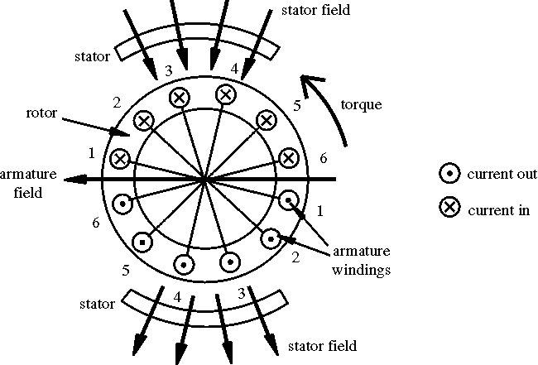

**Exercise A.1.**

Fill in the gaps with the right word(s) from the text:

1. Electric generators are also known as __________ (DC) or __________ (AC).

2. The basic principle of how electricity is generated is called __________.

3. The principle of electromagnetic __________ was discovered by the British physicist Michael Faraday.

4. A machine that converts __________ energy into electrical energy is called a generator.

5. A machine that converts electrical energy into mechanical energy is called a __________.

6. In a generator, the conductors which cut the magnetic field carry the __________ current.

7. In a motor, the conductors that cut the electric field carry the __________ current.

**Exercise A.2.**

Match two halves (one from column A, one from column B) to form correct sentences:

**A**

1. A motor is a machine that -

2. The principle of electromagnetic induction -

3. Electrical engineering -

4. Electricity may be used to -

5. A machine that converts mechanical energy into electrical energy –

6. If a wire is passed so that it crosses the magnetic lines of force, -

**B**

a – is the basic principle of how electricity is generated.

b – produce a magnetic field.

c – converts electrical energy into mechanical energy.

d – an electric current will flow along it.

e – is a branch of science and technology.

f – is called an generator

**Exercise B.2.**

Choose the right word(s) from among those given to fill in the following sentences:

1. A…………….is a portion of a machine which remains fixed with respect to rotating parts, especially the collection of stationary parts in the magnetic circuits of a machine.

a) rotor

b) alternator

c) stator

d) turbine

The electric machines perform the ………… conversion of energy and they are reversible.

a) electromechanic

b) synchronous

c) asynchronous

d) generator

3. For the mechanical power we use the following symbol: ………….

a) PE

b) PM

c) JL

d) DC

4. The ………………. current electric machines can be: synchronous and asynchronous machines.

a) direct

b) alternating

c) single-phase

d) three-phase

5. A synchronous generator operated by a steam gas turbine is called …………… .

a) a hydro-generator

b) a turbo-generator

c) an atomic generator

d) a wind generator